TUTORIAL 6 — STEP-BY-STEP SOLUTION
Sales Forecast and Sales & Operations Planning
Detailed Student Edition — aligned with the official answer key
Footloose Sport Shoes — Production Plan for 2023
Method based on Chapter 4 of
Concepts in Enterprise Resource Planning, 3rd ed. (Monk & Wagner)

How to use this guide
This document solves the two tutorial activities and explains every step as if you have never built a forecast or a production plan before. Read it top to bottom the first time. After that, the coloured boxes are quick reference:
The coloured boxes
Orange “Worked example” boxes show the full arithmetic for one month, line by line.
Blue “Key idea” boxes hold the single most important point of a section.
Green “Check” boxes prove a rule is satisfied (e.g. inventory never below the safety stock).
Red “Watch out” boxes are the mistakes students most often make.

This version matches the official answer key
All numbers here line up with your tutorial’s answer key, including the production plan and the unrounded August value (5,922.5).
Two things are flagged where they come up: the answer key’s January capacity is a typo (it should be 5,760, not 5,580), and the production plan is only one of several valid answers (explained in section 3.8).

The vocabulary you need (read this first)
Six words appear again and again. If these make sense, the whole tutorial makes sense.
Word | What it means (in plain English)
Sales forecast | Our best guess of how many pairs of shoes customers will buy each month. We are predicting the future from last year’s sales.
Promotion | A special marketing push (a sale, an advert) that temporarily lifts demand above its normal level. We treat promotion sales separately from “normal” sales.
Base (or base demand) | The “normal,” repeatable level of sales with the one-off promotion bumps stripped out. Growth is applied to this clean number, not to a promotion spike.
Capacity | The most pairs the factory can physically make in a month if it runs flat out: pairs-per-hour × hours-per-day × working-days.
Utilization | How hard the factory is working = production ÷ capacity, written as a %. We keep it at 99% or less so there is room for breakdowns and changeovers.
Inventory | Finished shoes sitting in the warehouse, ready to sell. It goes up when we make more than we sell, and down when we sell more than we make.
Safety stock | A minimum cushion of inventory (here, 100 pairs) we always try to keep, so a surprise in demand does not cause a “stockout” (running out).
Production plan | Our decision of how many pairs to actually make each month — balancing demand, capacity and inventory.

1. The big picture — where this fits in the book
Chapter 4 of the textbook describes how a manufacturer plans production as a chain of steps:
Sales forecasting → Sales & operations planning (S&OP) → Demand management → MRP → Detailed scheduling → Production
This tutorial covers only the first two steps. In the book these are taught with a snack-bar company called Fitter Snacker; Footloose Sports is the very same problem with shoe numbers, so we copy the book’s method exactly.
- Step 1 — Sales forecasting answers “how many shoes will we sell each month next year?” We start from last year’s sales, remove last year’s promotion bumps to get a clean base, grow that base by an expected percentage, then add the promotions planned for this year.
- Step 2 — Sales & operations planning answers “how many shoes should we make each month, and can the factory keep up?” We turn the forecast into a production plan that meets demand, respects capacity, and keeps a safety-stock cushion.

The single most important idea in this whole tutorial
You cannot just “make exactly what you forecast” every month. The factory has a fixed capacity, and demand is seasonal (higher around festive periods).
When a busy month needs more shoes than the factory can make that month, you must make extra shoes earlier, in the quiet months, and store them as inventory.
That is exactly Footloose’s December problem: forecast demand is 6,477 pairs, but the December factory can only make 5,702 pairs at 99% — less than demand. The gap is covered from inventory built up earlier in the year.

The information the tutorial gave us
Before calculating, let us list every fact from the question in one place. Everything below comes straight from the tutorial sheet.
Word | What it means (in plain English)
Last year’s sales (2022) | Given month-by-month in the “Previous Year” row (4,000 in Jan rising to 6,300 in Dec).
Last year’s promotions | +200 pairs in June, +400 in November, +400 in December.
Expected growth | 3% more than last year.
This year’s promotions | A holiday promotion: +500 pairs in November and +400 in December. (Important: there is NO June promotion this year.)
Factory speed | 40 pairs per hour, 8 hours per working day.
Working days | Vary by month (16 to 22) — given in the spreadsheet.
Opening inventory | 500 pairs already in the warehouse at the start (end of the prior December).
Safety stock | 100 pairs minimum at all times.
Capacity rule | Keep utilization at 99% or less.
Festive note | Expect higher demand around June and December, so plan a buffer.
Product mix | Three shoe models share production: Air Storm 50%, Sky High 30%, Gravity Kicks 20%.

2. Activity 1 — Building the Sales Forecast
We fill in five new rows underneath the data we were given. Think of it as a little pipeline: each row takes the row above it and changes it slightly, until the last row is our forecast. Here is the plan of attack:
Previous year − last-year promotion = Base → ×3% growth → Base projection + this-year promotion = FORECAST
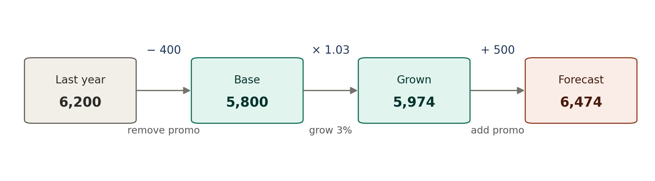
Figure 1 — The forecast as a pipeline: take last year’s number, remove its old promotion, grow it 3%, then add this year’s promotion (November shown).

2.1 What each row means, and why we need it
- Previous Year base = Previous Year − last year’s promotion. Why subtract? Last year a promotion artificially boosted June, November and December. If we grew those inflated numbers, we would be assuming the promotion happens again at the same time — double-counting it. So we strip the promotion out first to reveal the “normal” demand.
- Growth [3%] = base × 3%. The company expects 3% more customers than last year (from trade research). We apply that 3% to the clean base. 3% as a decimal is 0.03.
- Base projection = base + growth. This is the expected normal demand for 2023, before any promotion.
- Promotion (this year). We now add back the promotions the company actually plans for 2023: +500 in November, +400 in December. Nothing in June this year.
- Sales forecast = base projection + this year’s promotion. The final answer. In months with no promotion, the forecast is simply the base projection.

2.2 A full worked example — let us do November end-to-end
November is the most interesting month because it has both a last-year promotion (which we remove) and a this-year promotion (which we add). Follow all five steps:
November, step by step
Start: last year’s November sales = 6,200 pairs
Step 1 — remove last year’s promo: 6,200 − 400 = 5,800 (this is the base)
Step 2 — apply 3% growth: 5,800 × 0.03 = 174 (the growth in pairs)
Step 3 — base projection: 5,800 + 174 = 5,974
Step 4 — this year’s promo: + 500 pairs (planned holiday promotion)
Step 5 — sales forecast: 5,974 + 500 = 6,474 pairs

Two quick contrast examples so the pattern is clear:
January (a plain month — no promotion either year)
Base: 4,000 − 0 = 4,000
Growth: 4,000 × 0.03 = 120
Base projection: 4,000 + 120 = 4,120
Forecast: 4,120 + 0 = 4,120 (no promo, so forecast = base projection)

June (had a promo LAST year, none THIS year)
Base: 5,500 − 200 = 5,300 (we remove last year’s +200 June promo)
Growth: 5,300 × 0.03 = 159
Base projection: 5,300 + 159 = 5,459
Forecast: 5,459 + 0 = 5,459 (no June promo planned this year)

About August — the half-pair (matches the answer key)
August base is 5,750. Growth = 5,750 × 0.03 = 172.5 pairs — a half-pair.
The official answer key leaves this UNROUNDED, so August’s forecast is 5,922.5. This guide matches the key and keeps 5,922.5 throughout.
In real life you cannot make half a shoe, so you would round to 173 (forecast 5,923). Both are accepted — but use 5,922.5 to match the key.

2.3 Every month’s calculation in one table
The table below repeats the five steps for all twelve months, so you can see exactly how each forecast number was produced. Read each row left to right; the last column is the answer. (November and December are highlighted because they carry the new promotions.)
Month | Prev. year | − LY promo | = Base | Base × 3% | = Growth | = Base proj. | + TY promo | = FORECAST
Jan | 4,000 | 0 | 4,000 | 120 | 120 | 4,120 | 0 | 4,120
Feb | 4,000 | 0 | 4,000 | 120 | 120 | 4,120 | 0 | 4,120
Mar | 4,500 | 0 | 4,500 | 135 | 135 | 4,635 | 0 | 4,635
Apr | 5,000 | 0 | 5,000 | 150 | 150 | 5,150 | 0 | 5,150
May | 5,000 | 0 | 5,000 | 150 | 150 | 5,150 | 0 | 5,150
June | 5,500 | 200 | 5,300 | 159 | 159 | 5,459 | 0 | 5,459
July | 5,500 | 0 | 5,500 | 165 | 165 | 5,665 | 0 | 5,665
Aug | 5,750 | 0 | 5,750 | 172.5 | 172.5 | 5,922.5 | 0 | 5,922.5
Sep | 6,000 | 0 | 6,000 | 180 | 180 | 6,180 | 0 | 6,180
Oct | 6,000 | 0 | 6,000 | 180 | 180 | 6,180 | 0 | 6,180
Nov | 6,200 | 400 | 5,800 | 174 | 174 | 5,974 | 500 | 6,474
Dec | 6,300 | 400 | 5,900 | 177 | 177 | 6,077 | 400 | 6,477
In the “Base × 3%” column, August is 172.5 (a half-pair). The answer key keeps it unrounded, so it flows straight through to the forecast as 5,922.5.

2.4 The completed Sales Forecast table (the answer to Activity 1)
This is the same information laid out exactly like the tutorial spreadsheet, with months across the top. The bold orange row is your forecast.
Sales Forecasting | Jan | Feb | Mar | Apr | May | June | July | Aug | Sep | Oct | Nov | Dec
Previous Year (pairs sold) | 4,000 | 4,000 | 4,500 | 5,000 | 5,000 | 5,500 | 5,500 | 5,750 | 6,000 | 6,000 | 6,200 | 6,300
Promotion (last year) |  |  |  |  |  | 200 |  |  |  |  | 400 | 400
Previous Year base | 4,000 | 4,000 | 4,500 | 5,000 | 5,000 | 5,300 | 5,500 | 5,750 | 6,000 | 6,000 | 5,800 | 5,900
Growth [3%] | 120 | 120 | 135 | 150 | 150 | 159 | 165 | 172.5 | 180 | 180 | 174 | 177
Base projection | 4,120 | 4,120 | 4,635 | 5,150 | 5,150 | 5,459 | 5,665 | 5,922.5 | 6,180 | 6,180 | 5,974 | 6,077
Promotion (this year) |  |  |  |  |  |  |  |  |  |  | 500 | 400
Sales forecast | 4,120 | 4,120 | 4,635 | 5,150 | 5,150 | 5,459 | 5,665 | 5,922.5 | 6,180 | 6,180 | 6,474 | 6,477

How to put this in Excel (months Jan–Dec are columns C–N)
Type these formulas once in the January column (C) and drag them across to December (N). Storing the 3% in one cell ($C$27) means you can change it in a single place and the whole forecast updates.
Spreadsheet row / cell | Excel formula (and what it means)
Previous Year base (row 7) | =C5-N(C6) — last year’s sales minus last year’s promotion
Growth [3%] (row 8) | =C7*$C$27 — base × 3% (the answer key leaves this unrounded)
Base projection (row 9) | =C7+C8 — base plus growth
Promotion this year (row 10) | 500 and 400 — just type these into Nov (M10) and Dec (N10)
Sales forecast (row 11) | =C9+N(C10) — base projection plus this year’s promotion
Tip: N(…) turns a blank promotion cell into 0, so the formula never shows an error.

3. Activity 2 — Building the Sales & Operations Plan
Now we decide how many shoes to make each month. There are four things to work out, in this order: (a) how much the factory can make — capacity; (b) how hard it is working — utilization; (c) how much warehouse stock we have — inventory; and (d) the actual production plan that ties it together. We will build them one at a time.

3.1 Capacity — how many pairs can the factory make?
Capacity is just a multiplication. The factory makes 40 pairs an hour and runs 8 hours a day, so it makes 320 pairs a day. Multiply by the number of working days in the month:
Capacity = 40 pairs/hour × 8 hours/day × working days
Because we must keep utilization at 99% or less, the most we are allowed to actually produce is 99% of capacity (the last column). Notice how the number of working days swings capacity around: February (16 days) is low, November (22 days) is high, and December (only 18 days) is surprisingly tight.
Month | Working days | Calculation | = Capacity (pairs) | Max at 99%
Jan | 18 | 40 × 8 × 18 | 5,760 | 5,702
Feb | 16 | 40 × 8 × 16 | 5,120 | 5,068
Mar | 20 | 40 × 8 × 20 | 6,400 | 6,336
Apr | 20 | 40 × 8 × 20 | 6,400 | 6,336
May | 20 | 40 × 8 × 20 | 6,400 | 6,336
June | 18 | 40 × 8 × 18 | 5,760 | 5,702
July | 18 | 40 × 8 × 18 | 5,760 | 5,702
Aug | 20 | 40 × 8 × 20 | 6,400 | 6,336
Sep | 20 | 40 × 8 × 20 | 6,400 | 6,336
Oct | 20 | 40 × 8 × 20 | 6,400 | 6,336
Nov | 22 | 40 × 8 × 22 | 7,040 | 6,969
Dec | 18 | 40 × 8 × 18 | 5,760 | 5,702

Why December is the problem month
December working days: 18
December capacity: 40 × 8 × 18 = 5,760 pairs
Most we may produce (99%): 5,760 × 0.99 = 5,702 pairs
But December demand is: 6,477 pairs
So at least: 6,477 − 5,702 = 775 pairs MUST come from inventory built up earlier

A typo in the official answer key — January capacity
The answer key shows January capacity = 5,580. That is incorrect. January has 18 working days, so 40 × 8 × 18 = 5,760 — exactly the same as June, which also has 18 days and is correctly shown as 5,760 in the same sheet.
This guide uses the correct 5,760. It does not change the plan (January utilization stays well under 99% either way), but if your marker checks against the key, this is the one number worth flagging.
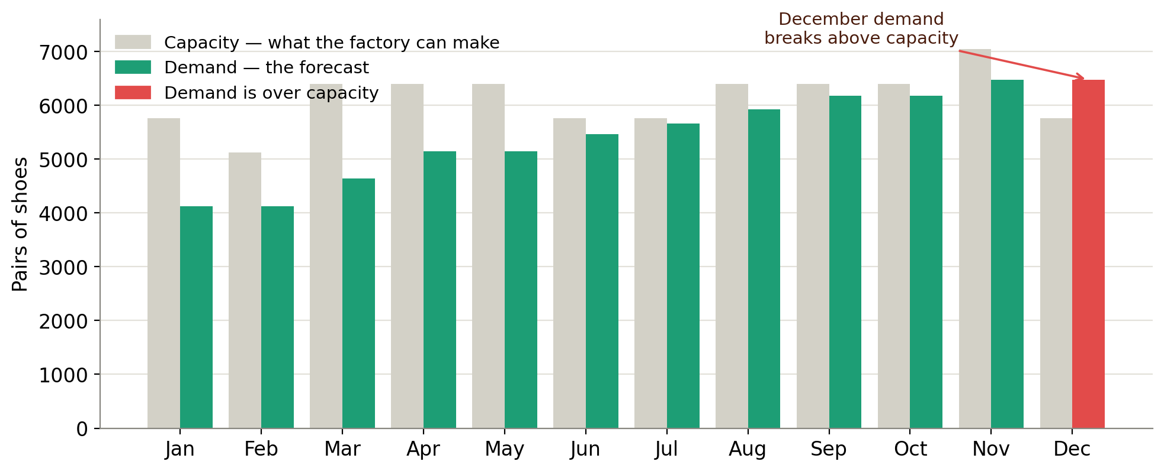
Figure 2 — Demand vs. capacity each month. Every month’s demand sits below the factory’s capacity except December, whose demand (red) breaks above it.

3.2 Inventory — the balancing equation
Inventory is like a bank account for shoes. Each month you add what you make and subtract what you sell:
Ending inventory = Beginning inventory + Production − Sales forecast
“Beginning inventory” for a month is simply last month’s ending inventory. We start in January with the 500 pairs already in the warehouse. The golden rule: ending inventory must never drop below the 100-pair safety stock.

3.3 The production plan — the key decision (and how it was built)
The production plan is not a formula; it is a decision the planner makes by trial-and-error, exactly as the textbook says. There is no single “right” plan — any plan works as long as all three rules below hold at once. (Section 3.8 shows a second, equally valid plan.) The plan below is the one in the official answer key.
- Rule 1 — never run out: ending inventory ≥ 100 (safety stock) every month.
- Rule 2 — never overload the factory: utilization (production ÷ capacity) ≤ 99% every month.
- Rule 3 — plan ahead for peaks: December cannot make all of its own demand, so build a cushion of inventory earlier in the year.

Here is the reasoning behind the answer key’s plan, in order:
- December cannot keep up, so we need a cushion. December demand is 6,477 but the factory can make at most 5,702 that month. The difference must come from inventory already in the warehouse, so we must build a cushion before December.
- Build the cushion early — in January. January is quiet (forecast only 4,120) and has spare capacity. So we produce 5,000 in January, which lifts inventory from the opening 500 straight up to 1,380 in one step (January utilization is only 86.8%).
- Hold the cushion steady. From February to October we produce exactly the forecast each month, so inventory stays flat at 1,380 — a large, comfortable buffer that also covers the June festive season.
- Top up in November. November produces 6,600 (a little above its 6,474 forecast), nudging inventory up to 1,506 just before the December peak.
- Draw the cushion down in December. December produces 5,500 (95.5% utilization) and lets inventory fall to 529. Demand is fully met, and the year still ends well above the 100-pair safety stock.

The answer key’s plan in one paragraph
Produce 5,000 in January to build the warehouse up to a 1,380-pair cushion in one go. Hold that 1,380 cushion from February to October by producing exactly the forecast. Top up slightly in November (6,600 → inventory 1,506), then in December produce 5,500 and draw the cushion down to 529 — still safely above the 100-pair safety stock. Every month meets demand and stays under 99% capacity, and the cushion easily covers the June and December festive peaks.

3.4 Following the inventory month by month
This is the heart of Activity 2. Each row applies the equation Beginning + Production − Forecast = Ending. Watch inventory jump to 1,380 in January, hold flat through October, rise to 1,506 in November, then fall to 529 in December.
Month | Beginning inv. | + Production | − Forecast | = Ending inv. | ≥ 100?
Jan | 500 | 5,000 | 4,120 | 1,380 | ✓ yes
Feb | 1,380 | 4,120 | 4,120 | 1,380 | ✓ yes
Mar | 1,380 | 4,635 | 4,635 | 1,380 | ✓ yes
Apr | 1,380 | 5,150 | 5,150 | 1,380 | ✓ yes
May | 1,380 | 5,150 | 5,150 | 1,380 | ✓ yes
June | 1,380 | 5,459 | 5,459 | 1,380 | ✓ yes
July | 1,380 | 5,665 | 5,665 | 1,380 | ✓ yes
Aug | 1,380 | 5,922.5 | 5,922.5 | 1,380 | ✓ yes
Sep | 1,380 | 6,180 | 6,180 | 1,380 | ✓ yes
Oct | 1,380 | 6,180 | 6,180 | 1,380 | ✓ yes
Nov | 1,380 | 6,600 | 6,474 | 1,506 | ✓ yes
Dec | 1,506 | 5,500 | 6,477 | 529 | ✓ yes

The three months that move, fully worked
January: 500 (begin) + 5,000 (make) − 4,120 (sell) = 1,380 ending
November: 1,380 (begin) + 6,600 (make) − 6,474 (sell) = 1,506 ending
December: 1,506 (begin) + 5,500 (make) − 6,477 (sell) = 529 ending
Result: December demand of 6,477 is fully met; the year ends at 529, well above safety stock.

Check — Rule 1 satisfied
The lowest the inventory ever reaches is 529 pairs (December) — far above the 100-pair safety stock. It never comes close to a stockout all year.
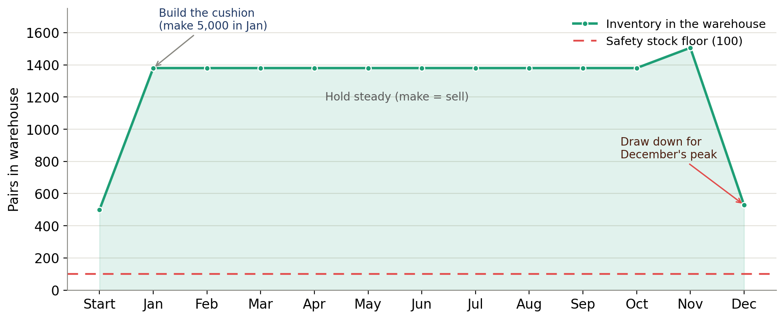
Figure 3 — Inventory across the year: build the cushion early (the January jump), hold it steady, then draw it down for December — always above the safety-stock floor.

3.5 Utilization — is the factory within 99%?
Utilization shows how hard the factory works each month. Divide what we plan to make by what the factory can make:
Utilization = Production ÷ Capacity
We need every month at 99% or below. In the answer key’s plan the busiest month is July at 98.4% (5,665 ÷ 5,760); December sits at 95.5% because we deliberately make only 5,500 there and lean on the inventory cushion. Every month is comfortably within the 99% limit.
Month | Production | Capacity | Calculation | = Utilization | ≤ 99%?
Jan | 5,000 | 5,760 | 5,000 ÷ 5,760 | 86.8% | ✓
Feb | 4,120 | 5,120 | 4,120 ÷ 5,120 | 80.5% | ✓
Mar | 4,635 | 6,400 | 4,635 ÷ 6,400 | 72.4% | ✓
Apr | 5,150 | 6,400 | 5,150 ÷ 6,400 | 80.5% | ✓
May | 5,150 | 6,400 | 5,150 ÷ 6,400 | 80.5% | ✓
June | 5,459 | 5,760 | 5,459 ÷ 5,760 | 94.8% | ✓
July | 5,665 | 5,760 | 5,665 ÷ 5,760 | 98.4% | ✓
Aug | 5,922.5 | 6,400 | 5,922.5 ÷ 6,400 | 92.5% | ✓
Sep | 6,180 | 6,400 | 6,180 ÷ 6,400 | 96.6% | ✓
Oct | 6,180 | 6,400 | 6,180 ÷ 6,400 | 96.6% | ✓
Nov | 6,600 | 7,040 | 6,600 ÷ 7,040 | 93.8% | ✓
Dec | 5,500 | 5,760 | 5,500 ÷ 5,760 | 95.5% | ✓

Check — Rule 2 satisfied
The highest utilization all year is 98.4% (July). Every other month is lower. The factory is never overloaded.

3.6 Splitting production into the three shoe models
The last step of S&OP breaks the single “total pairs” figure into the individual products Footloose actually makes. The split is fixed: 50% Air Storm, 30% Sky High, 20% Gravity Kicks. For each month:
- Air Storm = production × 50%. Example (December): 5,500 × 0.5 = 2,750.
- Sky High = production × 30%. Example (December): 5,500 × 0.3 = 1,650.
- Gravity Kicks = production × 20%. Example (December): 5,500 × 0.2 = 1,100. Since 50% + 30% + 20% = 100%, the three models always add back to the exact production total.
Month | Production | Air Storm (50%) | Sky High (30%) | Gravity Kicks (20%) | Sum check
Jan | 5,000 | 5,000×0.5 = 2,500 | 5,000×0.3 = 1,500 | 1,000 | 5,000
Feb | 4,120 | 4,120×0.5 = 2,060 | 4,120×0.3 = 1,236 | 824 | 4,120
Mar | 4,635 | 4,635×0.5 = 2,317.5 | 4,635×0.3 = 1,390.5 | 927 | 4,635
Apr | 5,150 | 5,150×0.5 = 2,575 | 5,150×0.3 = 1,545 | 1,030 | 5,150
May | 5,150 | 5,150×0.5 = 2,575 | 5,150×0.3 = 1,545 | 1,030 | 5,150
June | 5,459 | 5,459×0.5 = 2,729.5 | 5,459×0.3 = 1,637.7 | 1,091.8 | 5,459
July | 5,665 | 5,665×0.5 = 2,832.5 | 5,665×0.3 = 1,699.5 | 1,133 | 5,665
Aug | 5,922.5 | 5,922.5×0.5 = 2,961.25 | 5,922.5×0.3 = 1,776.75 | 1,184.5 | 5,922.5
Sep | 6,180 | 6,180×0.5 = 3,090 | 6,180×0.3 = 1,854 | 1,236 | 6,180
Oct | 6,180 | 6,180×0.5 = 3,090 | 6,180×0.3 = 1,854 | 1,236 | 6,180
Nov | 6,600 | 6,600×0.5 = 3,300 | 6,600×0.3 = 1,980 | 1,320 | 6,600
Dec | 5,500 | 5,500×0.5 = 2,750 | 5,500×0.3 = 1,650 | 1,100 | 5,500
The “Sum check” column equals the production every month — proof the split is consistent.

3.7 The completed Sales & Operations Planning table (the answer to Activity 2)
Here is everything assembled in the tutorial’s layout. The first “Dec” column is the prior December, used only to carry the 500-pair opening inventory into January. The bold orange row is your production plan.
Sales & Operations Planning | Dec | Jan | Feb | Mar | Apr | May | June | July | Aug | Sep | Oct | Nov | Dec
Sales Forecast |  | 4,120 | 4,120 | 4,635 | 5,150 | 5,150 | 5,459 | 5,665 | 5,922.5 | 6,180 | 6,180 | 6,474 | 6,477
Production Plan |  | 5,000 | 4,120 | 4,635 | 5,150 | 5,150 | 5,459 | 5,665 | 5,922.5 | 6,180 | 6,180 | 6,600 | 5,500
Inventory | 500 | 1,380 | 1,380 | 1,380 | 1,380 | 1,380 | 1,380 | 1,380 | 1,380 | 1,380 | 1,380 | 1,506 | 529
Working Days |  | 18 | 16 | 20 | 20 | 20 | 18 | 18 | 20 | 20 | 20 | 22 | 18
Capacity (shipping) |  | 5,760 | 5,120 | 6,400 | 6,400 | 6,400 | 5,760 | 5,760 | 6,400 | 6,400 | 6,400 | 7,040 | 5,760
Utilization |  | 86.8% | 80.5% | 72.4% | 80.5% | 80.5% | 94.8% | 98.4% | 92.5% | 96.6% | 96.6% | 93.8% | 95.5%
Air Storm [50%] |  | 2,500 | 2,060 | 2,317.5 | 2,575 | 2,575 | 2,729.5 | 2,832.5 | 2,961.25 | 3,090 | 3,090 | 3,300 | 2,750
Sky High [30%] |  | 1,500 | 1,236 | 1,390.5 | 1,545 | 1,545 | 1,637.7 | 1,699.5 | 1,776.75 | 1,854 | 1,854 | 1,980 | 1,650
Gravity Kicks [20%] |  | 1,000 | 824 | 927 | 1,030 | 1,030 | 1,091.8 | 1,133 | 1,184.5 | 1,236 | 1,236 | 1,320 | 1,100

How to put this in Excel (months Jan–Dec are columns D–O; the prior Dec is column C)
Spreadsheet row / cell | Excel formula (and what it means)
Sales Forecast (row 15) | =C11 — pulls each month’s forecast from Activity 1
Production Plan (row 16) | type the values — the planner’s decision — found by trial-and-error
Inventory (row 17) | =C17+D16-D15 — beginning inventory + production − forecast
Capacity (row 19) | =$C$28*$C$29*D18 — 40 × 8 × working days
Utilization (row 20) | =D16/D19 — production ÷ capacity (format the cell as %)
Air Storm (row 21) | =0.5*D16 — 50% of production (unrounded, to match the key)
Sky High (row 22) | =0.3*D16 — 30% of production
Gravity Kicks (row 23) | =0.2*D16 — 20% of production; the three add to exactly D16

3.8 The production plan is not unique — a second valid answer
Because the production plan is a trial-and-error decision, more than one plan can be correct. The answer key (used above) carries a large cushion all year. A leaner plan keeps only the opening 500 pairs, builds a small amount just before December, and ends exactly on the 100-pair safety stock. Both meet every rule — they simply trade inventory holding cost against how tightly they run.
What to compare | Answer-key plan (used in this guide) | Leaner alternative
January production | 5,000 (build the cushion early) | 4,120 (just meet demand)
Inventory most of the year | ≈ 1,380 pairs | ≈ 500 pairs
November production | 6,600 | 6,609
December production | 5,500 | 5,702
Inventory at year end | 529 | 100 (exactly safety stock)
Busiest month (utilization) | 98.4% (July) | 99.0% (December)
Meets all three rules? | Yes | Yes

Which one should you submit?
Use the answer-key plan above — it is the model answer your marker will compare against.
But if your numbers differ from a classmate’s, you are not necessarily wrong: check that your plan meets demand every month, keeps inventory ≥ 100, and keeps utilization ≤ 99%. If it does, it is a valid plan too.

4. Checking your answer (do this before you submit)
Run through these five checks. If all five pass, your tables are correct.
- Forecast logic: did you remove last year’s promotions before applying 3% growth, and add this year’s promotions afterwards (Nov +500, Dec +400, nothing in June)?
- Inventory never below 100: in the answer key’s plan the minimum is 529 (December) — comfortably above the 100-pair safety stock.
- Utilization never above 99%: the highest is July at 98.4%; every month is within the 99% limit.
- December demand met: 6,477 pairs are supplied even though the factory makes only 5,500 in December — the rest comes from the inventory cushion built up earlier.
- Products add up: Air Storm + Sky High + Gravity Kicks equals the production plan in every column.

5. Common mistakes to avoid
The five traps students fall into
1. Growing the wrong number. Always remove last year’s promotion FIRST, then grow. Growing 6,200 instead of 5,800 for November inflates the answer.
2. Adding a June promotion this year. There isn’t one — only November and December have promotions in 2023.
3. Making exactly the forecast every month. That breaks in December, where the factory cannot keep up. You must build inventory ahead of time.
4. Forgetting the opening inventory is 500, not 100. The 100 is the safety-stock floor; the 500 is what you actually start with.
5. Letting utilization tip over 99%, or letting inventory fall below 100. Re-check both rows after any change to production.

6. Why a company needs an integrated (ERP) system
Notice how many departments had to share the same numbers to fill in these two tables:
- Marketing & Sales provided the sales history and the promotion plans — the inputs to the forecast.
- Production provided the working-day calendar and the capacity, and owns the production plan.
- Supply Chain / Purchasing will take this production plan into the next step (MRP) to order materials at the right time.
In a company without an integrated system (the book’s Fitter Snacker before ERP), these numbers live in separate, out-of-date spreadsheets that are not shared. The December capacity problem would only be noticed when the factory physically ran out of time — forcing costly overtime or lost sales. An ERP system keeps the forecast, the calendar, the inventory and the production plan in one shared database, so the “build a cushion early” decision can be made calmly, well before December. That is the real lesson of Chapter 4.

The whole tutorial in two sentences
Forecast 2023 demand by growing the promotion-cleaned 2022 base by 3% and adding the new November and December promotions.
Then build a production plan that meets that demand, keeps at least 100 pairs of safety stock, stays at or below 99% capacity, and carries an inventory cushion (built up early in the year) so December’s capacity shortfall is covered.

A completed, self-calculating Excel workbook accompanies this guide. Every cell is driven by the formulas shown above, so you can change any input — the growth rate, a promotion, or the working days — and watch the entire plan recalculate instantly.

